SOP Creator Inputs
Program Overview/Background: The purpose of Unstructured Attributes (UAs) audit is to establish a consistent and systematic approach for conducting content Quality Audits checks of product attribute values generated by the PLE (Progressive Listing Experience) prod model, as well as benchmark available attribute pre-fill use cases developed for Listing experiences. More than one model is available, and in this case, we will focus on Quicklist audits.

Task Scope:
Evaluate the model UAs generated content for Quicklist UA audits. This process involves independent evaluations of model-generated values to ensure objectivity and consistency. It also aims to precisely assess model performance, ensuring that evaluation metrics consistently reflect accuracy and reliability, thereby maintaining a high standard of quality.

It will be done through checking the following parameters:
- Relevancy: Check whether the generated content is related to the product/ similar to the attribute being listed
- Correctness: Check whether the generated attributes information is accurate. This check need not be performed when the check for relevancy fails
- Duplication Check: Applicable to Modular Titles only. This check ensures no word or phrase from item_name is repeated in title_differentiation (excluding connecting words such as articles, prepositions, and conjunctions). Binary Pass/Fail scoring per Modular Title.
- Consistency: Check whether the generated attributes content is consistent across attributes
- Instruction Adherence: A check performed at the Unstructured Attribute (UA) level to assess whether the UA content generated by the LLM adheres to the instructions provided by the seller. Each UA - Modular Title-Title/PD/BP - is evaluated independently against the applicable Seller Instructions. This check is applicable only when Seller Instructions are provided.

Audit Steps:

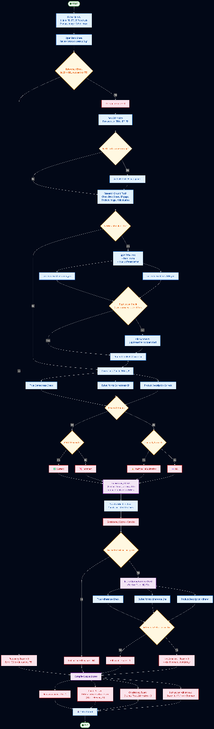

Supporting documentation for context:
For Quicklist content generation: https://quip-amazon.com/pagQAqiXH0bI#TFJ9BAB80ct

Escalation Paths:
Provides clear guidance on when and how to get help, preventing delays and ensuring complex cases receive expert review.
When to Escalate:
- Evidence is contradictory with no clear resolution
- Technical system failures such as tool down which prevent audit completion
- Dispute about audit decision interpretation
- Cases requiring expert judgment beyond SOP scope
How to Escalate:
- Level 1 : Post in team slack group with issue summary
- Level 2 : Connect with GCO SMEs (devbarba@, rsuprith@)
- Level 3 : Contact GCO Operations Manager (selicka@, susayyed@)

Author: Barbara De Vito (devbarba)
SME: Barbara De Vito (devbarba), Supritha R (rsuprith)
SOP Verified Date: 3/30
Change Approver: Silvia Selicka (Selicka), Lakshman Kolasani (kolasl)

